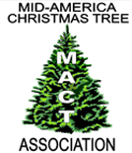MID-AMERICA CHRISTMAS TREE ASSOCIATION NEWSLETTER

***Spring 2018***

***Fall 2019 Donna Cackler, Executive Administrator midamericachristmastreeassoc@gmail.com***  [***www.midamericachristmastree.com***](http://www.midamericachristmastree.com)

**News from the MACT –**

The Mid-America Christmas Tree Association (MACT) was hosted by the Wisconsin Christmas Tree Producers Association for a combined meeting and trade show in Walworth County, Wisconsin on August 15 and 16, 2019. MACT was joined by the Illinois and Indiana Christmas Tree Associations.

This meeting was a different format in that part of the meeting was at the host farm and the rest was at the local fairgrounds. This allowed for a farm who did not have room for the tents *and* parking to be able to host a meeting of this size. The concept of using the two separate locations was a great learning experience for us and it opened the door to show other farms alternative ways to host. The vendors had lots of room, parking was plentiful, and the overall feedback was positive.

Another new concept was having the Food Trucks for “lunch on your own” instead of the traditional catered lunch. I must admit that I was a bit skeptical when told “two” trucks would be enough for over 200 people. The lines moved quickly, and I was impressed. So far, the feedback I have received is pretty much split 50/50 between using Food Trucks or having a catered lunch.

Attendee’s gathered at Country Side Trees in Walworth County on Thursday afternoon to learn from our hosts, the Feltham family. Along with Christmas trees, they also raise elk.

Our first farm stop was the “elk farm” where the elk are raised. We got to learn about the elk along with all the regulations and requirements that go along with raising them. Elk are not very social but a few of them came close enough that we were able to see them. Watching them run through the field was beautiful to see. Also, at this location is where the wreath and greenery operations are based. Ruth Feltham did a wreath demonstration, followed by a question and answer session.

We traveled down the road to our next stop where the retail operation is based. Field demonstrations included shearing with an electric Beneke, painting trees with colorant, and a self-propelled tree cutting machine. Trees, wreaths and greenery are sold at this location. Also featured was their gift shop that is filled with many unique items, including elk antlers in many shapes and sizes. Holly Feltham presented a session titled “Technology Tutoring with Holly” where she worked one-on-one with attendee’s for assistance with social media.

Our final stop of the day was at the Walworth County Fairgrounds in Elkhorn, Wisconsin. A vendor reception was held followed by a catered dinner. Jon Schultz of Northwoods Evergreen was honored with the Mike Gwinner Award.

The MACT recognizes individuals for their contribution(s) to the Christmas tree industry over the years through the presentation of the Mike Gwinner Award. Jon Schultz was nominated by Ron Evans who had the pleasure of sharing some of Jon’s contributions over the years and presenting him with this award.

Friday’s activities were held at the Walworth County Fairgrounds. A wide variety of seminars covered topics such as websites, social media marketing and advertising online; fertilizer alternative options; nursery grower panel; pros, cons and tips for hosting classes at your farm; and “hands on” opportunities to design porch pots.

We had a great selection of vendors in attendance and many took the opportunity to preorder supplies to save on shipping. A complete list of vendors can be found on the MACT website [**www.midamericachristmastree.com**](http://www.midamericachristmastree.com)**.**  Highlights of this meeting can be found on the MACT website under the MACT Summer Meeting tab.

In case you missed this year’s meeting, please plan to join the MACT in 2020. Our host farm will be Dull’s Tree Farm near Thorntown, Indiana on July 24 & 25, 2020.

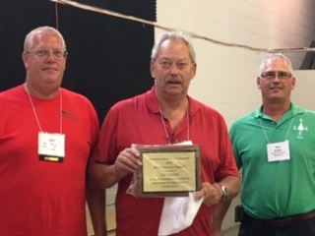

Jon Schultz of Northwoods Evergreen & Wire was the recipient of the Mike Gwinner Award for his contributions to the Christmas Tree Industry. Pictured L-R are MACT President Bill Holesinger, Jon Schultz and MACT member Ron Evans who nominated Jon Schultz and presented this award to him.

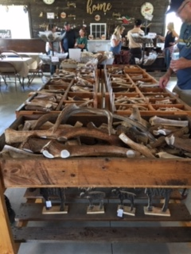 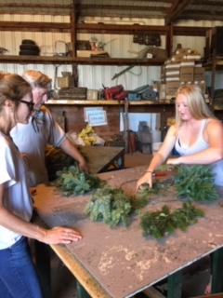

Ruth Feltham demonstrating wreath making.

Antlers for sale in the gift shop – many sizes to choose from.

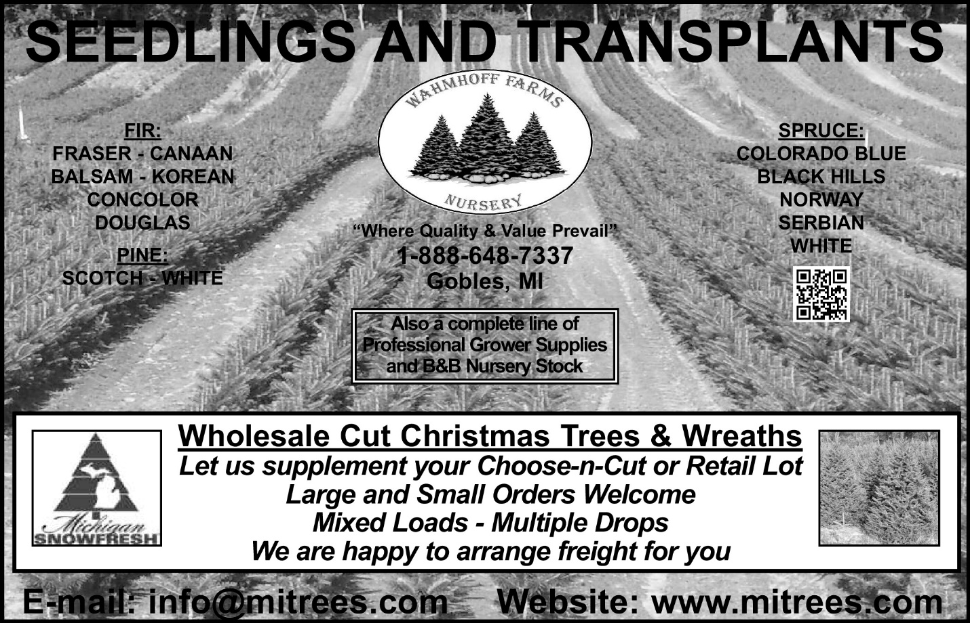

2019-2020 MEMBERSHIP LIST

The membership list is published on our website

[www.midamericachristmastree.com](http://www.midamericachristmastree.com)

QUESTIONS?

Please contact Donna Cackler, Executive Administrator

740-815-6107

midamericachristmastreeassoc@gmail.com

***Santa’s Wholesale Supply SupplySSSSupplySuSupply***

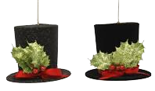

**1(800) 772-6827**



***Exclusive line of:***

*Christmas Ribbon *Wreath Rings

*Wreath Decorations *Pine Cones

*Glue & Glue Guns *Wire & Easels

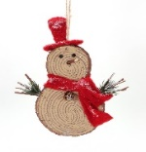

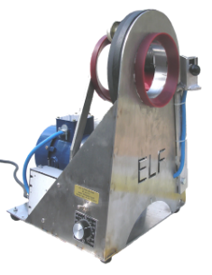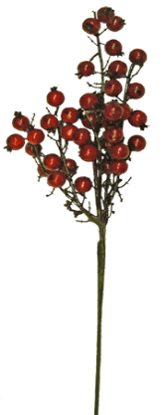

**Ribbon Samples on Request**

·  Best Service at Lowest Price

· Same Day Shipping

·  Free Catalog

Exciting New Designer

Ribbon Line

Elf Garland Machine

***Visit us at www.santasupplies.com***

***Click on “The Sale Room” for fantastic sale items. ***

www.wreathrings.com

email:santa@santasupplies.com

www.santasupplies.com

**Mid-America Christmas Tree Association**

**2019-20 Officers and Directors**

**Officers (3-year terms [no more than 2 successive terms]**

**President Vice-President Secretary/Treasurer**

Bill Holesinger - 22 [3] Dennis Duke – 22 [3] Joe Eise – 21 [reappoint 21]

7250 Garden Plain Rd. 8023 Mt. Zion Church Rd. 25882 S. Lohman Rd.

Fulton, IL 61252 Philpot, KY 42366 Wright City, MO 63390

309-887-4892 270-281-5555 636-745-7488

[jeise1@hotmail.com](mailto:jeise1@hotmail.com)

**Executive Administrator**

Donna Cackler [appointed 04/01/16]

5025 Cackler Rd.

Delaware, OH 43015

740-815-6107

[midamericachristmastreeassoc@gmail.com](mailto:midamericachristmastreeassoc@gmail.com)

**Board of Directors* (3-year term)**

Bill Cackler -22[3] Scott Heeren – 22 [1] Joe Evans – 22 [2]

5025 Cackler Rd. 5715 N 750 E 1538 N CR400 W

Delaware, OH 43015 Hamlet, IN 46532 Danville, IN 46122

740-524-5311 574-540-1869 (cell) 317-797-3266 (cell)

[cacklerfarms@gmail.com](mailto:cacklerfarms@gmail.com) sbheeren@gmail.com [ewpfarms@aol.com](mailto:ewpfarms@aol.com)

Jeff Koning – 18 (21) [1] Jerry Peterson – 21 [2]

P.O. Box 283 873 26th St.

Bloomingdale, IN 47832 Allegan, MI 49010

765-592-6693 269-673-2440

[j](mailto:j)effk55@msn.com [info@petersons-riverview.com](mailto:info@petersons-riverview.com)

*Year in parentheses indicates the end of term.

*Number in bracket is number of terms.

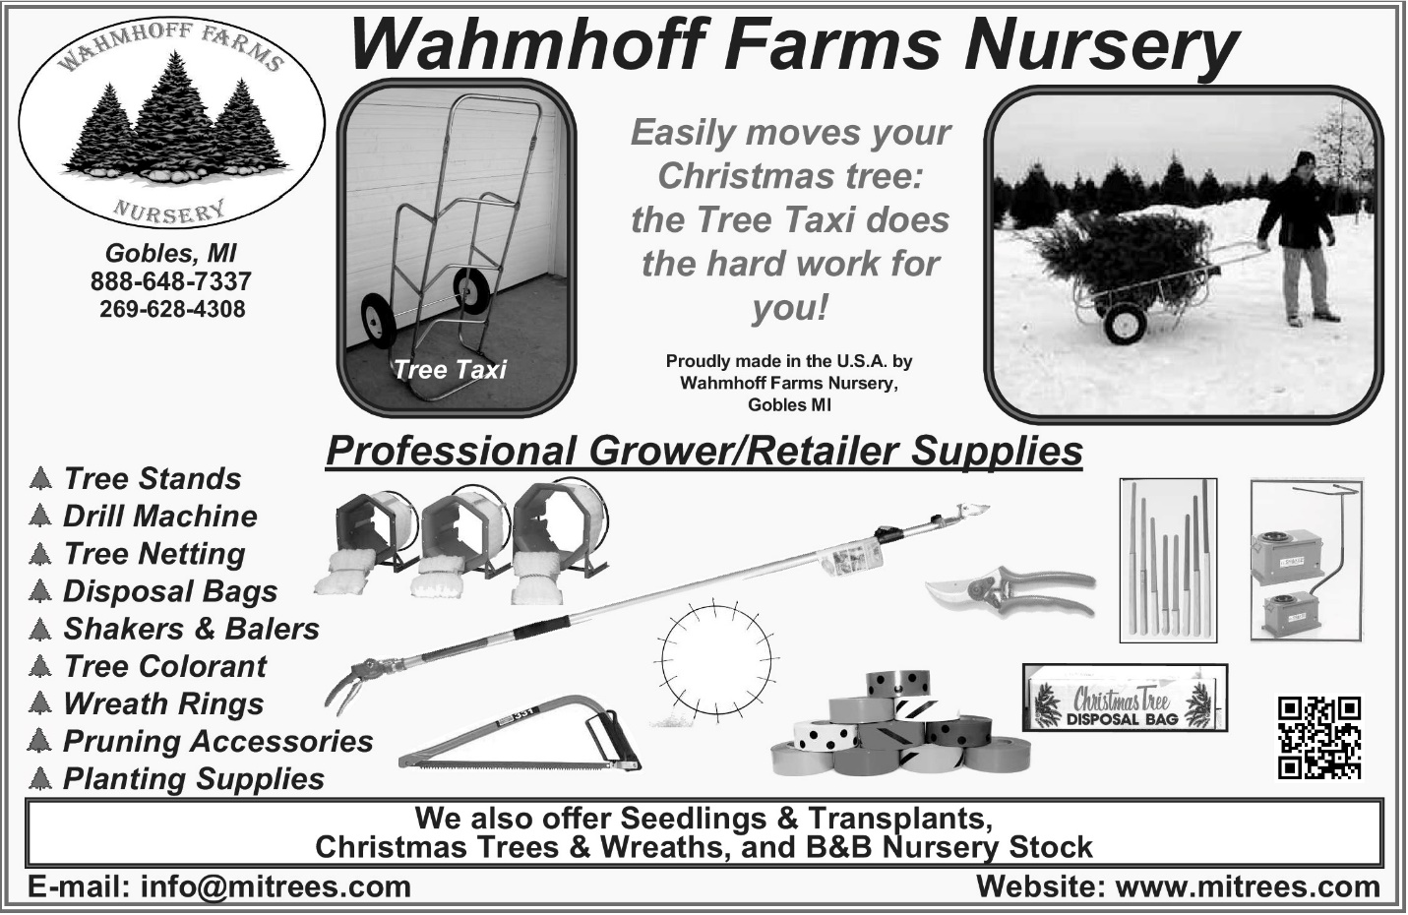

**\*\*SAVE THE DATE\*\***

**What: 2020 MACT Summer Meeting**

**When: July 24-25, 2020**

**Where: Dull’s Tree Farm in Thorntown, Indiana**

Dull’s Tree Farm was started by Tom and Kerry Dull in 1985. This family run business features 40 acres of trees. Son Lucas and his wife Dana joined the farming operation in 2013 and helped grow the business by adding a fall season known as Dull’s Pumpkin Harvest consisting of u-pick pumpkins, a corn maze, and many other entertaining activities for people to enjoy. This is just a snapshot of the many activities at this farm. Plan now to join us!

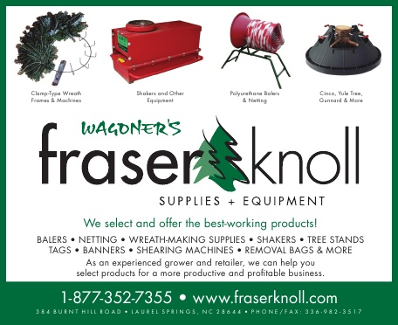

**INTERVIEW REQUEST FROM MARTHA STEWART LIVING MAGAZINE**

The following email was received:

Hi MACT team,

My name is Jillian, and I'm a freelance writer for Martha Stewart Living's website. I'm working on a piece on why our readers should get a Christmas tree from a local farm, and I would love to include the MACT in the piece! Is there anyone in the association who would be able to answer the following questions via email by EOD Thursday, Sept. 12?

If you would please let me know either way, I would greatly appreciate it!

Here are my questions—and the more detail you can provide, the better!

1. What are three benefits to getting a Christmas tree from a local farm (as opposed to via a vendor, or at a grocery or garden store, for example)? The benefits could be for the customer themselves—i.e., saving money or a greater selection, for example—or for the general public—i.e., it's better for the local economy, etc. Whatever benefits you list, please be as detailed as possible in explaining these benefits!

2. Beyond the benefits mentioned you above, are there any other reasons people should buy their Christmas tree from a local farm? A reason that experience is better or more enjoyable? Or gets them a better tree? Whatever these reasons may be, please be as detailed as possible in explaining these reasons.

3. Is there anything else you might like to add to this topic?

THE RESPONSE SUBMITTED -

Three benefits of getting a Christmas tree from a local farm –

1. Freshness – you cannot get a fresher tree than the one you cut yourself. The fresh cut on a tree allows it to absorb water (ie: drink) which keeps it fresh once it has been severed from its roots. After a tree has been cut for a few hours it will form a sap seal (which is much like a scab seals a cut). Once this happens, it will not drink any water. A fresh cut will need to be made. A tree purchased from a lot has been cut for several days, if not weeks. Thus, that tree has been deprived of water since.
2. Selection – where else can you select from hundreds to thousands of trees in one location? A typical tree farm grows more than one species of tree, so you have not only the various heights to choose but different species as well. There is nothing more peaceful than walking thru a field of Christmas trees and seeing Mother Nature’s handiwork at its finest.
3. Supports local agriculture – Christmas trees are an agriculture crop the same as grain crops (corn/soybeans). The main difference is it takes 7-10 years to grow a tree to marketable height. Whereas grain crops are an annual crop. There are fewer Christmas tree farmers compared to grain farmers due to the time commitment involved. It also means it is a long time until you see a return on your investment.

Why people should buy their Christmas tree from a local farm –

Buying your Christmas tree from a local farm supports a small business and local agriculture. Not only that the goal of most Christmas tree farmers is to educate the consumers who visit their farm about the process of growing Christmas trees – it is a year-round process. Preparations are made prior to planting the young trees from getting equipment serviced and ready, to field preparation and then the actual planting process. Tree farmers have a window of time which young trees must be planted for optimal survival and growth. Next comes the shearing (shaping) process. Some of the young trees must be taught to stand-up straight. Every tree must be visited yearly. The stores all have “Christmas in July” sales but for those in the Christmas tree industry, this is when work on the farm is the busiest getting trees ready for harvest. It truly is Christmas in July on a Christmas tree farm.

The experience of getting a Christmas tree from a local farm is better or more enjoyable –

The experience of getting a Christmas tree from a local farm “creates a memory” and often becomes a family tradition. It also is a great family time experience. We often see several generations of a family coming together for their annual tree cutting tradition.

Buying a Christmas tree from a local farm gets a better tree –

Buying a Christmas tree from a local farmer helps you find the perfect tree. Beauty is in the eye of the beholder and each tree is unique. No two are the same. Each person/family has an idea of what their perfect tree is and the search for it becomes a family adventure.

Other thoughts –

Buying a Christmas tree from a local farm helps the environment. Christmas trees are a renewable resource - for every tree cut, two more are planted. Christmas trees absorb carbon dioxide (greenhouse gas) and they produce oxygen. They are composed of plant tissue and 100% biodegradable. Christmas trees are recyclable. They are also PVC and lead free.

Submitted by:

Donna Cackler, Executive Administrator

Mid-America Christmas Tree Association (MACT)

*Time will tell what we see on Martha Steward Living’s website!*

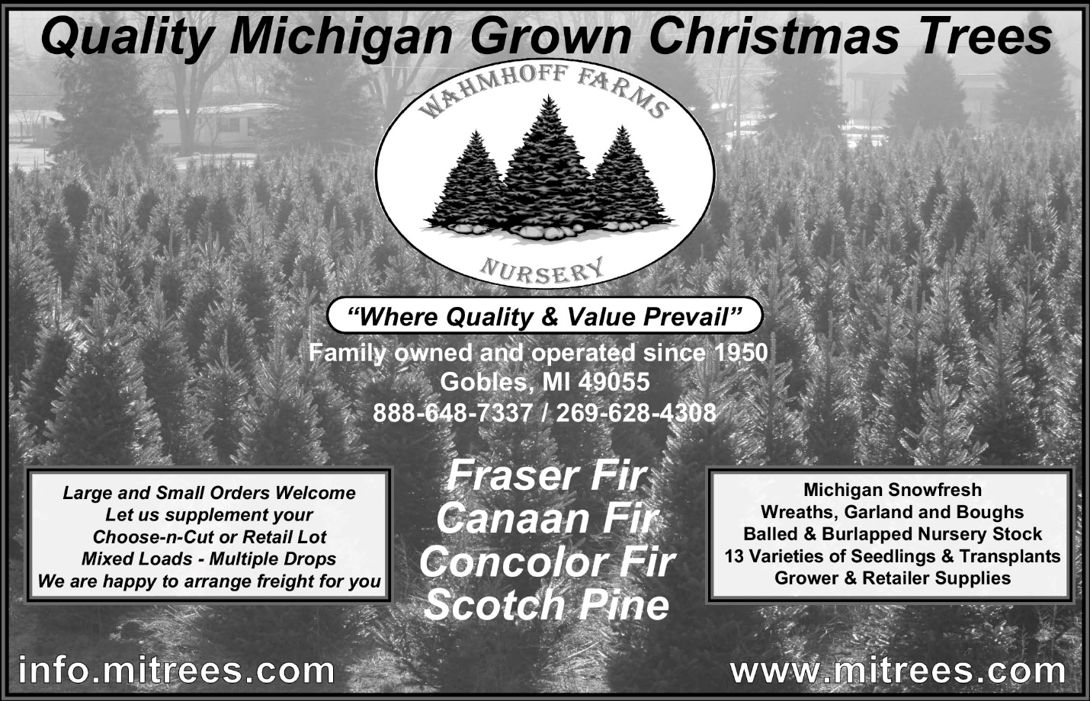

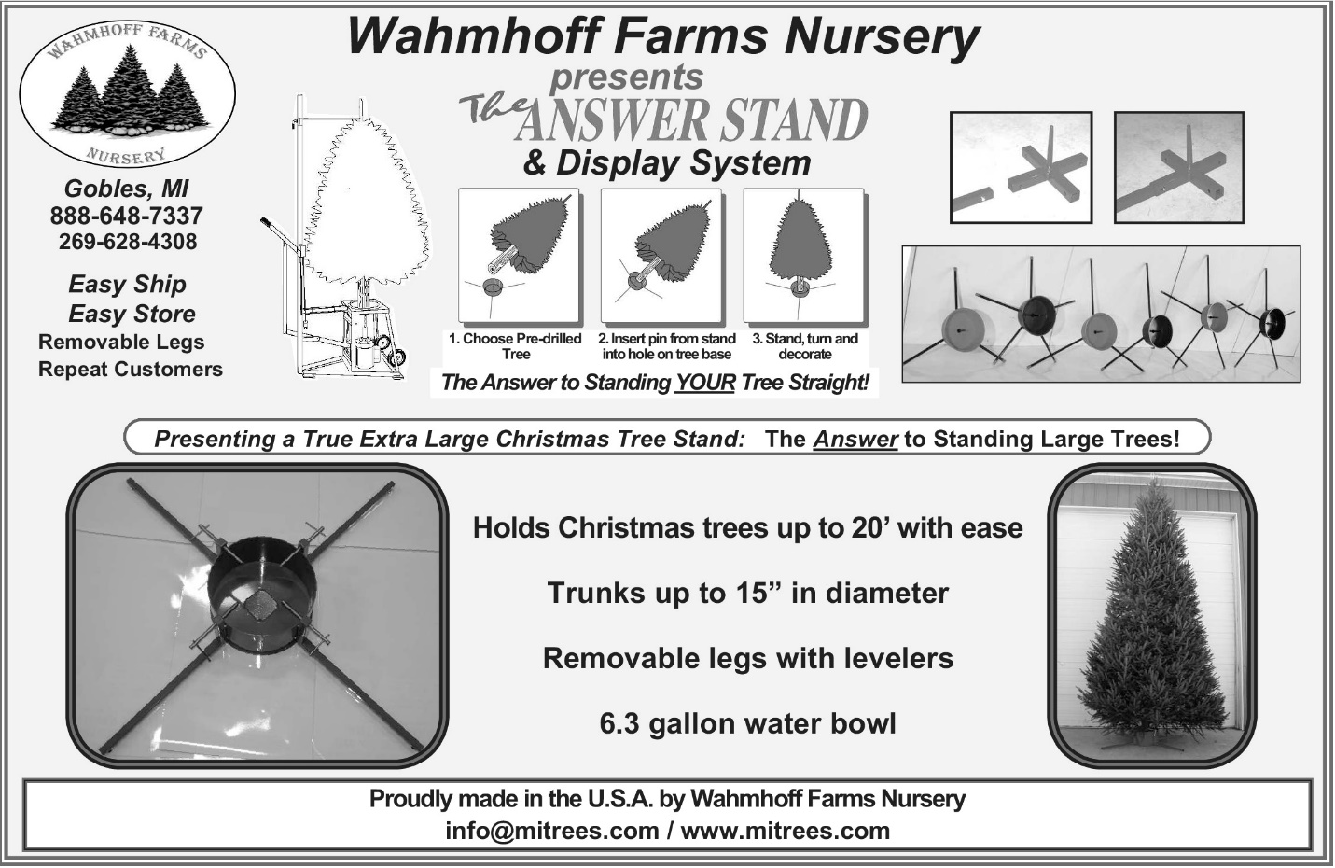

MACT

c/o Donna Cackler

5025 Cackler Rd.

Delaware, OH 43015