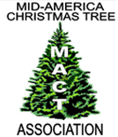

MID-AMERICA CHRISTMAS TREE ASSOCIATION NEWSLETTER

***Spring 2019 Donna Cackler, Executive Administrator***

***midamericachristmastreeassoc@gmail.com***

***www.midamericachristmastree.com***

**WE’RE GOING TO WISCONSIN!**

**August 15 & 16th, 2019**

**To be Hosted by**

**Countryside Trees in Walworth, Wisconsin**

**combined with Wisconsin, Illinois and Indiana**

**Christmas Tree Associations**

*Glen and Becky Feltham of Countryside Trees*

On Thursday, August 15, everyone will drive to the “elk farm” to learn about value-added products such as wreaths and antler dog bones and to see the elk. A short drive from there will get you to the “tree farm” to learn about giving the customer what they want, rotation techniques, bough harvesting, the giftshop, equipment used, tree movement/accountability/sales area, and to take a walk through the fields.

You may also have individual help from Holly setting up social media accounts.

We will be at the Walworth County Fairgrounds <https://www.walworthcountyfair.com/>   
on Friday, for seminars,trade show, WI tree contest, and evening banquet.

(There is also a rodeo on the grounds that evening.)

*​*

**Please visit our website [www.midamericachristmastree.com](http://www.midamericachristmastree.com) for farm photos and meeting schedule. Registration materials will be mailed to you by the Wisconsin Christmas Tree Producers Association in May.

## **Hotels for 2019 Summer Meeting**

You may want to check for promotions/rates you may get with memberships you may have (AAA, AMAC, AARP, Farm Bureau, etc.).

***Hotel Name***

**Elkhorn Lodging**

**​**

AmericInn Lodge & Suites Elkhorn        Hampton Inn Elkhorn         
210 E. Commerce Court  400 W. Hidden Trail   
Elkhorn, WI 53121  Elkhorn, WI 53121

262-723-7799  262-723-2360

1.9 mi from fairgrounds/10.6 mi to farm 1.9 mi from fairgrounds/13.7 mi to farm

Crossroads Motel        Thomas Motel                                         
N6476 US Hwy 12  840 N. Wisconsin St   
Elkhorn, WI 53121  Elkhorn, WI 53121

262-742-2300  262-723-2955

4.2 mi from fairgrounds/15.6 mi to farm 1.5 mi from fairgrounds/11.6 mi to farm

**Delavan & Williams Bay - \*\*** Rooms blocked**\*\***

​

​Comfort Suites -  *\*\** til 6/30 Delavan Inn                                           
313 Bauer Pkwy  215 E. Walworth Ave

Delavan, WI 53115  Delavan, WI 53115

262-740-1000  262-728-9100

7 mi from fairgrounds/5 mi to farm 6.5 mi from fairgrounds/4.4 mi to farm

Evergreen Motel    Lake Lawn Resort **til 6/16                                        
740 E. Geneva St.  2400 E. Geneva Hwy 50   
Delavan, Wi 53115  Delavan, WI 53115

262-728-5454  262-728-4487

7.2 mi from fairgrounds/4.5 mi to farm 7 mi from fairgrounds/8.2 mi to farm  
                                        
Super 8 Motel        Sky Lodge Inn

518 Borg Rd.  5560 Hwy 50   
Delavan, WI 53115  Delavan, WI 53115

262-728-1700  262-728-9399

7.3 mi from fairgrounds/5 mi to farm 7.3 mi from fairgrounds/6.7 mi to farm  
                                    
Bayside Motel          Harbor View                                              
47 W. Geneva St.  60 Johnson Terr.   
Williams Bay, WI 53191  Williams Bay, WI 53191

262-245-6366  262-245-5036

7 mi from fairgrounds/5.3 mi to farm 7.7 mi from fairgrounds/6.3 mi to farm

**Lake Geneva**                                . 

​Budget Host              Chateau Royale                                             
1060 Wells St.  135 Main St.    
Lake Geneva, WI 53147  Lake Geneva, WI 53147

262-248-1809  262-248-9630

12017 mi from fairgrounds/12.4 mi to farm 10.7 mi from fairgrounds/11.7 mi to farm

Grand Geneva                          The Ridge Hotel                          
7036 Grand Geneva Way  W4240 State Rd 50   
Lake Geneva, WI 53147  Lake Geneva, WI 53147

262-248-8811  262-248-9121

11.1 mi from fairgrounds/13.9 mi to farm 7.6 mi from fairgrounds/7.3 mi to farm  
                                                   
Lake Geneva Motel        Comfort Suites                                      
524 Wells St.  300 E. Main St  
Lake Geneva, Wi 53147  Lake Geneva WI 53147

262-248-3664  262-248-4100

11.5 mi from fairgrounds/11.8 mi to farm 10.5 mi from fairgrounds/11.9 mi to farm  
                                                  .   
French Country Inn            Harbor Shores                               
W5869 Brick Church Rd  300 Wrigley Dr  
Lake Geneva, WI 53147  Lake Geneva, WI 53147

262-245-5220  262-248-9180

8.2 mi from fairgrounds/7.9 mi to farm 10.8 mi from fairgrounds/11.4 mi to farm  
                                                  .   
Mill Creek Hotel    Bella Vista Suites                                              
123 Center St.  335 Wrigley Dr.   
Lake Geneva WI 53147  Lake Geneva, WI 53147

262-248-6647  262-248-2100

11.3 mi from fairgrounds/11.3 mi to farm 10.9 mi from fairgrounds/11.4 mi to farm  
                                                
The Cove of Lake Geneva              The Geneva Inn                    
111 Center St.  N2009 State 120   
Lake Geneva, WI 53147  Lake Geneva WI 53147

262-249-9460  262-248-5680

11.4 mi from fairgrounds/11.3 mi to farm 10.9 mi from fairgrounds/11.3 mi to farm

                                             ​

**Camping:**

**​**

There is a campground on site at the Walworth fairgrounds. Campsites can be rented for $40 per night. You receive a nice camp spot with electric and water hook-up, with dump stations on the grounds. Showers and restrooms are also on site.

Book online: <https://www.walworthcountyfair.com/p/facilities/ElkhornCampgrounds>

NOTE: you will see that there is “no camping” from August 13-18. There is for our group. What you do is fill out the form completely and, in the box, where you request a campsite number, you will tell them you are with the Christmas tree convention. Go ahead and submit your form and payment.

Cancellations must be done 7 days prior to arrival.

<https://www.elkhorncampgrounds.com/map-layout>    
Our convention activities will be in the Activity Center and nearby buildings. Choose a site close to those.

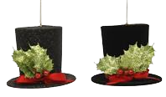

***Santa’s Wholesale Supply SupplySSSSupplySuSupply***

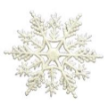

**1(800) 772-6827**

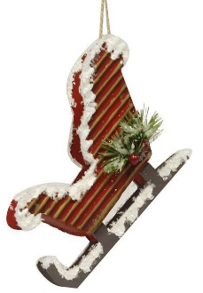

***Exclusive line of:***

*Christmas Ribbon *Wreath Rings

*Wreath Decorations *Pine Cones

*Glue & Glue Guns *Wire & Easels

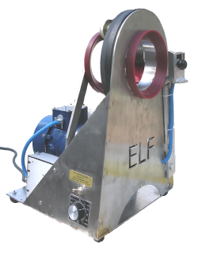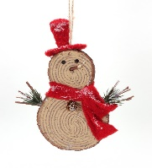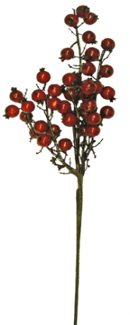

Exciting New Designer

Ribbon Line

**Ribbon Samples on Request**

·  Best Service at Lowest Price

· Same Day Shipping

·  Free Catalog

Elf Garland Machine

www.wreathrings.com

www.santasupplies.com

email:santa@santasupplies.com

***Visit us at www.santasupplies.com***

***Click on “The Sale Room” for fantastic sale items. ***

SPOTLIGHT ON OUR HOST:

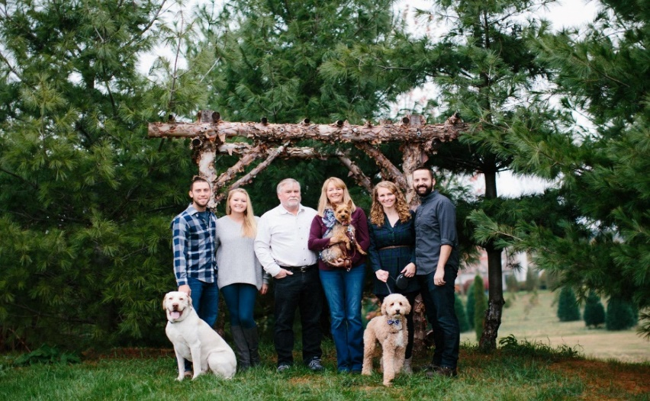

Country Side Trees in Walworth, Wisconsin is owned by Glen and Becky Feltham. They have a 75-acre cut your own tree farm with Fraser fir, Canaan fir, Blue spruce, White pine and Scotch pine. They grow all their own bough material for wreaths, garland and grave blankets that they make themselves , and there are 10 elk on one of their properties.

Glen planted his first seedlings in 1982 on his father’s farm and worked as an airline mechanic for many years as he continued to plant trees.

The first 20 years, Glen and Becky kept growing trees. They sold them out of their garage until they build a gift shop down the road. They went from initially planting 500 trees per year of White pine and Scotch pine to 5,000 trees per year and then to 10,000 trees per year of more varieties.

Through the recession, Glen and Becky started a second business, CST Antlers, selling elk antler dog bones. The business came naturally because they raised elk and trees were not selling like they used to. They kept on planting trees, trying different marketing techniques and believing things would get better. They planted fewer trees, but with a higher success rate by switching to planting trees in an 8-foot grid. It made the cut your own experience more consumer friendly too.

In the last 10 years, they moved the retail location down the road about a mile. In 2012, they built a pavilion at that location to keep their employees out of the weather and to house their shaking and baling equipment. In 2016, they built a new gift shop right next to it.

Today, Glen and Becky run the farm with the help of their two daughters, Holly and Ruth. The girls plan to take over the farm one day. They are moving forward, planting more trees instead of slowing down. They sell their elk antler dog bones in the gift shop at the farm and advertise their Christmas tree farm at their pet events. The store is open a few days a week from spring to Christmastime.

The Feltham family hopes that you will plan to attend to learn more about their marketing strategies, growing techniques, wreath business, growing brush/boughs for wreaths, raising elk, selling antlers, land use and rotation and value-added sales.

As a bonus, Holly will be available to help you with social media. They are calling it “Technology Tutoring with Holly”. She will be your “millennial” to help you with:

* Setting up a Facebook or Instagram Business Page
* Posting on Facebook or Instagram
* Creating an ad on Facebook or Instagram
* Scheduling so you do not have to post in real time
* What to post online
* Signing up with Square

(*Please bring along your laptop/smart phone/tablet and your specific questions you want answered. We will schedule 10-minute time slots, you can sign up when you register for the convention, so watch your mail for details.)*

**THANK YOU, MINNESOTA!**

MACT was asked to speak at the Minnesota Christmas Tree Association Winter Meeting in Minneapolis to share what MACT was all about. President Bill Holesinger accepted this invitation. He along with his wife, Donna attended this meeting in early March.

Minnesota CTA had good attendance at this meeting and President Holesinger talked about MACT followed by a question and answer session. He also passed out brochures about MACT.

In attendance was a grower from Wisconsin who had attended our meeting with Michigan last summer. He talked about his experience there. This was a bonus for an audience member to see what we do.

We are thankful for this invitation and opportunity to share our message.

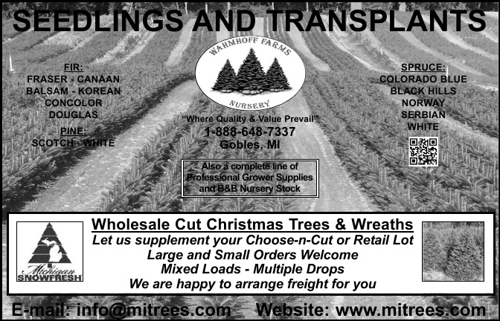

**Wanted: New Growers**

***By Donna Cackler***

As Bill and I have attended numerous Christmas tree association meetings over the past 30 years, we are no longer the “kids”. All of us are getting older and gray hair and baldness dominates those in attendance. We, like mainstream agriculture are aging and younger members are few and far between. How can we attract new growers and how can we help them avoid the mistakes we all made along the way? It is a long time until payday as we all know.

An economics professor in college made a statement one day that we have never forgotten. He told us there were three ways to get into farming – 1) inherit it, 2) marry into it; and 3) buy it – and he did not recommend #3.

Personally, we did #3 and started from scratch by purchasing the homestead farm from Bill’s grandfather’s estate. We worked full-time off the farm while raising our children and planting more trees every year. This adventure started 30 years ago in 1989.

Bill has been active in recruiting and mentoring new growers for the past 10 years. He has taught planting, shearing, how to take a soil test, read soil maps, etc.

This past year at the end of December we hosted our first “New Grower Seminar” at the farm for new and prospective growers. The Ohio Christmas Tree Association sponsored this event. We had a good turn-out ranging from those who are planning to plant, to those who have already planted but not yet harvested, to those who have purchased an existing farm and need to learn the “ropes”.

The seminar covered a variety of topics – beginning with the economics – what is in it for the grower and a budget. This tree budget that Bill has developed is formatted like a land-grant university would use for grain and forage crops but adapted for Christmas trees.

We asked all participants to bring the soils map for their farm and soil test results for fields they plan to plant in if they had them. This is what Bill calls “reading the tea leaves”. The goal is to teach what we have learned over the past 30 years of Christmas tree production and spare the others the costly mistakes we have all made.

Why are we doing this? We see our growers aging and few younger growers getting into the business. We need to see younger growers getting into the business to be the future of the Christmas tree industry. Particularly, we need cut your own farms adjacent to the large metropolitan areas of the country to meet the demand.

Bill is a retired high school science teacher who taught agricultural/physical/biology and environmental sciences for twenty-six years. He wrote textbooks for The Ohio State University as a graduate student and used this experience to write the New Growers Christmas Tree manual. He uses material from this manual in working with new growers.

What did we cover in this seminar? First, we started with the budgets, moved onto “reading the tea leaves” of the soil’s map/soil tests, matching the tree species to the site, timeline of a Christmas tree year – busy times, how to plan for those working full-time, etc. We concluded with a tour of the farm. We provided those in attendance with lots of handouts and our contact information. We avail ourselves to questions and have heard from almost everyone who attended. Bill will visit their farm upon request.

We also do one-on-one clinics. The first seminar was purposely planned between Christmas and New Year’s while the farm was set up for harvest/sales season. Our goal is to take this seminar on the road to other areas of the state with member farms being the host. So far this year, Bill has met with 13 new and potential growers.

We jokingly tell everyone we accept volunteers … we have one couple who wants to come help us plant this spring to learn how.

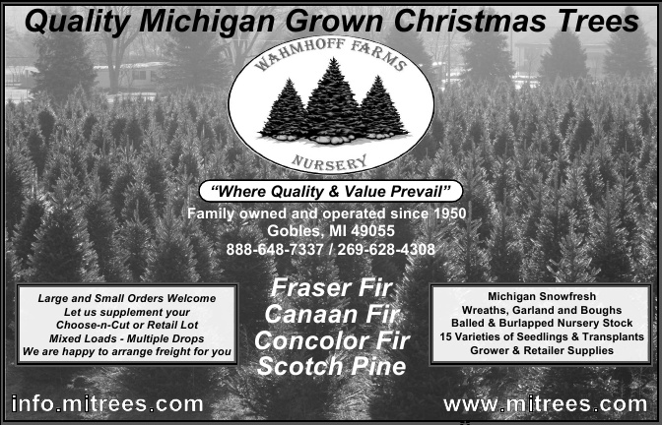

**SAGE WISDOM:**

“Sage Wisdom” is what we call advice we receive from more experienced/older Christmas tree growers. Such wisdom is usually spot on and something most of us had not heard of before.

The forsythia bush. Did you know when the forsythia bush blooms

Have “Sage Wisdom” to share? Please email me at midamericachristmastreeassoc@gmail.com.

**2019-2020 MEMBERSHIP DUES**

 Dues for the membership year 2019-2020 will be $35.00 per farm membership and will be due by July 1, 2019. Members not paid by the end of the show or those not attending by July 15, 2019 will be removed from the website and subscription list. See Donna Cackler for any changes. Each member must fill out a membership form even if no changes are needed.

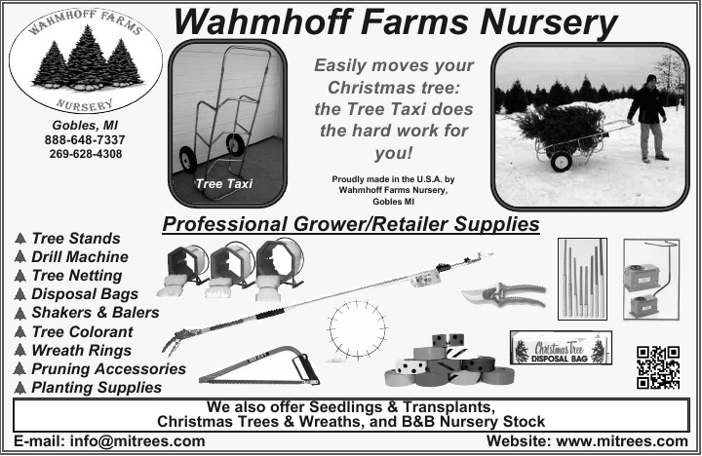



**Mid-America Christmas Tree Association (MACT)**

**2019-2020 Membership Application**

Company Name: ______________________________________________________

Contact Name(s): ______________________________________________________

Contact Address: ______________________________________________________

Phone: ____________________ Email: ____________________________________

Above Address: Home____ Farm____ Web Site: _____________________________________

Farm Address (if different from above): _______________________________________

Type of Operation:

_____ Tree Lot _____ Wreaths/Roping

_____ Wholesale _____ Grave Blankets/Greens

_____ Choose & Cut _____ Christmas Shop

_____ Nursery/Transplant B&B _____ Growing and Shearing Supplies

_____ Chemicals _____ New Grower (no sales yet)

_____ Related Industry _____ Other: __________________________________

List all State Association Memberships: _____________________________________________

Growers: Acres of Trees: ______ List all tree species that you grow: ______________________

______________________________________________________________________________

Exhibitor/Vendor: List type of merchandise offered: ___________________________________

______________________________________________________________________________

*Please check box if you would like the newsletter mailed to you*.

**Annual Dues = $35.00**

*(As an added benefit, members will receive a year’s subscription to Christmas Trees Magazine, if not receiving it through your state association, and a 50% discount on MACT newsletter advertisement rates)*

**Please make all checks payable to MACT and mail with this completed form to Donna Cackler, Executive** **Administrator, Mid-America Christmas Tree Association, 5025 Cackler Road, Delaware, Ohio 43015**. Web: [www.midamericachristmastree.com](http://www.midamericachristmastree.com) Email: [midamericachristmastreeassoc@gmail.com](mailto:midamericachristmastreeassoc@gmail.com)

Phone: 740-815-6107

Completed form required with payment, even if there are no changes. **All dues must be paid by July 1, 2019. Membership will be cancelled, and member will be removed from website July 15 if not paid.**

**IMPORTANT ITEMS TO NOTE:**

**Support our Vendors**

Visit the MACT website [www.midamericachristmastree.com](http://www.midamericachristmastree.com) for a list of vendors attending the Summer Show. This site is updated as registrations come in. Pre-order your supplies and save on shipping!

**Silent Auction**

Once again, we will be having a silent auction. Be sure to place your bid before they close on Friday at 12:00 pm. Winners will be announced at lunch on Friday.

**Donation of Items**

Please let us know at the registration table if you wish to donate an item for the silent auction. Forms will be available at the registration table. We really appreciate your support! Proceed help cover show costs.

**LOOKING FOR NEW BOARD MEMBERS**

This summer the MACT Board will be seeking nominations for new board members. Board member terms are three years in length and require participation in a Fall and Spring phone conference and attendance at the Summer board meeting held during the Summer Trade Show and Conference.

Please plan to attend the MACT meeting on Thursday, August 15th and consider contributing your time and talents to the MACT Board.

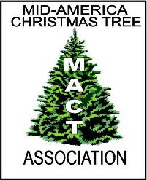**Mid-America Christmas Tree Association**

**Mike Gwinner/ Lois Graves Awards**

**Nomination Form**

**Please complete form, print, and mail to MACT, c/o Donna Cackler, Executive Administrator, 5025 Cackler Road, Delaware, Ohio 43015. All entries will be compiled and considered by the MACT Association Board.**

**Circle award that applies:**

**Mike Gwinner Lois Graves**

**Nominate ______**

**Farm Name or Organization nominate is associated with:**

**________**

**Years contributed to the Christmas Tree Industry:**

**Contributions to the industry:**

**Nomination Submitted by:**

**Farm Name or Organization of submitter: ____**

**Contact Information of submitter: Ph#**

**E-mail**

**Yes, I would like to introduce nominate at the Summer Meeting if he/she is selected.**

**No, I would prefer to not introduce nominate if he/she is selected.**

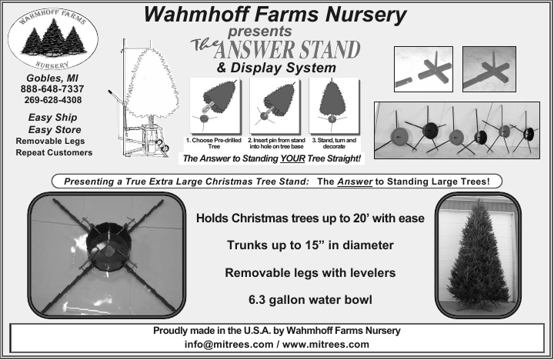

MACT

c/o Donna Cackler

5025 Cackler Rd.

Delaware, OH 43015